Magic Invitational Report: David Price
David Price

The Tour
1. When at a wine tasting, sit next to people who don't drink alcohol
I can't stress this one enough.
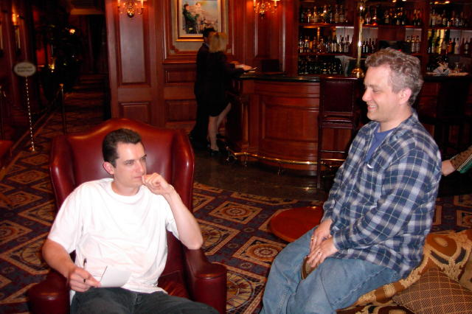
Mark Rosewater, Gary Wise, and Chris Pikula are great people to sit next to. They aren't big fans of drinking, so after you've finished your wine, you can often finish off their wine for them after they've taken their little girly sips. It's much better if they are in on it, but this can also be done to a lesser effect if they aren't. You just have to have a knack for pointing out interesting objects on the wall or out the window that will leave them looking in the wrong direction for long enough.
Not only are these three perfect to sit next to in a wine tasting for this reason, but all three are naturally "pre-drunk". They are loud and funny, and they often say things that other sober people would filter out before the words actually left the mouth. Thus, you can have the benefits of extra drinks while still maintaining the enjoyable company of seeming drunkards. It is truly the best possible situation.
2. When making an idiot of yourself, make sure that there is an even larger idiot right next to you
This is similar in nature to the phenomenon that is often witnessed at college bars, with sorority women. They often travel in pairs and one is significantly less attractive or more overweight than the other one. It's all a matter of contrast, really. For the good-looking one, it is a very advantageous situation. When a person views the pair of girls, the attractive one will seem that much more so when contrasted with the far less attractive girl standing next to her.
If you apply this formula to drunken idiots, it still holds true. It isn't a perfect analogy, as in the above situation a person is using a foil to accentuate their strong points, while in this scenario we are using one to downplay our weaknesses. The overall effect is the same, however. No matter how much of an idiot you make of yourself, you will look like a gentleman and a scholar next to Matt Vienneau, who is dangling over the edge of the boat in shark-infested waters, being belligerent with the ship's captain and crewmembers who are trying to prevent him from being involved in a deadly accident, drinking far more than he is humanly capable of and clumsily hitting on the female bartenders. The next day, all anyone remembers is what an incredible idiot Matt Vienneau was and they will have forgotten that you, too, were making a drunken idiot of yourself to a lesser degree.
Levels of drunken idiocy is a much more fluid thing than a person's attractiveness, so it is important to take stock of the situation periodically throughout the night of revelry. If you look around and you don't see an enormous drunken idiot, then YOU ARE IT.

The Tournament
3. Time limits are a good thing (and the Dutch are the slowest people on the planet)
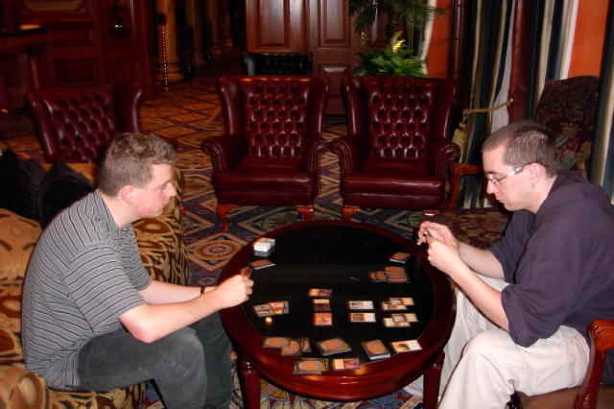
The Magic Invitational is a fun event, staged for the promotion of the game and for the enjoyment of the spectators, whether they are there in person or watching over the internet. For this reason, Mark Rosewater did away with time limits. He doesn't want to see draws in the Invitational, he wants a winner and a loser for each match. In addition, by eliminating time limits, Mark Rosewater successfully avoids the gray area of stalling from the game, which is certainly a plus. While this solved some problems, it also created plenty more.
In a normal match of Magic, one tries to decide on the best course of action, given that he or she is under time pressure and needs to make a decision in a reasonable amount of time. If there are no time limits, some players decide to think LONG and HARD about every freaking decision, making the game last way longer than it ever would normally. Most players didn't fall into this trap and played with the spirit of the Invitational, realizing that the players needed to sleep and unwind at the end of a day of playing Magic. Others, like Kamiel Cornelissen from the Netherlands, took so long that they were the last people playing in almost every round. This was compounded by the fact that Kamiel and his brother-at-arms, Tom van de Logt, showed up late at the beginning of each day and often after the lunch break, and resulted in the first two days of play lasting from nine in the morning until midnight. If it were anyone but those two, I would've thought that they were still drunk from partying the night before, but I'm sure they were simply sitting around at night and strategizing about how they were going to bore us to death on the following day.
Still, after two exhausting days of waiting for their matches to finish, throughout which the other competitors made jokes at their expense, verbally abused them, and applied every peer pressure trick that they knew, the two Dutchmen sped it up a little on the third day and allowed us to finish in time to actually enjoy the evening. To any future Invitationalists, play at a reasonable pace. Think quickly and if you can't figure it out, attack with all your creatures. I learned that from Truc Bui and it sometimes even works.
4. Don't Take Magic Too Seriously

There is a great deal of luck in Magic and no one is perfect, no matter how hard they try to be.
To be fair, I didn't learn this lesson all that well. I often forget it, especially when I've spent months practicing for a Pro Tour and lodge yet another mediocre performance. Still, while I take Magic very seriously when I play in a Pro Tour or a Grand Prix, I do remember to take it easy when I'm playing in the Magic Invitational or when I'm up against a ten year old in an 8 person draft at Neutral Ground - New York.
There is a great deal of luck in Magic and no one is perfect, no matter how hard they try to be. If you take an event like the Invitational too seriously, you'll end up beating yourself up over making a mistake to Ben Rubin and missing your chance to play in the finals against Jon Finkel, to whom you never lose in a tournament. While it's true that I wouldn't have to look at the smug look on Finkel's face as the Shadowmage Infiltrator beats the crap out of me in Extended and Standard for the next two years and I'd get to play with a new two-power goblin in my red beatdown deck, in the end, its not all that important. Dan Clegg was having a fine time up until the point where he lost to the German Juggernaut, Kai Budde, in the finals of this year's Invitational. That loss put him into a funk that lasted for the rest of the trip and probably his entire flight home and maybe a week or two after. It is simply not worth it. Dan Clegg won in my eyes, as he wasn't even the slowest player at the tournament and we got to have a great chat on the boat on tour day about life and poetry and music and important things like that.
It is especially important to remember this when you are playing in Friday Night Magic at the local store and a ten year old is smashing your face with cards that would never make the cut in one of YOUR draft decks. So you are mana screwed or you drew too many lands or he got passed some busted card or whatever, don't whine about it and make the kid feel bad for beating you. Suck it up, take it on the chin, and leave the kid with a good taste in his mouth so he comes back the next week and the week after. So you get angry when you get unlucky? Just do what I do, bottle it up inside and unleash it on someone who deserves it, like the next guy who tries to cheat you or anyone else in a game of Magic. Trust me, it's very satisfying.

The Aftermath
5. Chris Benafel is OK by me
He's a good man to go out with on your birthday. He has a great personality and seems to be on the up and up to me. Despite a few differences of opinion, I really like the guy. If he savagely cheats one of my friends, steals my girlfriend, or stabs me in the face, I will however be forced to retract this statement.
6. There is no such thing as a fun draft with Ryan Fuller
Last night in Cape Town, we are all pretty tired and we decide to do a two on two draft for kicks to waste a bit of time. I'm playing against Ryan Fuller and he launches into his ultra-competitive crap. I untap my permanents, draw a card, and he immediately asks "Are you done?" Does he think I'm going to forget to cast my spells and attack if he does this? Does he have someplace to go? After the third time he does this, I'm at my breaking point. He attacks with a 2/2 Scrivener, leaving his 2/3 flier on defense to stop my 2/2 Fledgling Imp, should I chose to attack, since he is at a lower life total. I chose to block, trading the Fledgling Imp for the Scrivner. He says, "Oh, I meant to attack with the 2/3 flier, too." Yeah, of course you did, now that you see that you are no longer going to have to hold off my freaking 2/2. I let him do it. I don't really care, but he sure sucks all the fun out of a room. Or maybe he just sucks.
7. Not telling your best friend that it is your birthday is a good way to make him angry
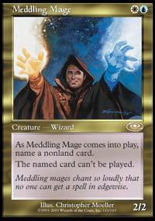
Truly a Deadguy
Or maybe Chris Pikula is just getting cranky in his old age. Fortunately, he is also going senile (or he may just have a short attention span), as he quickly forgot that he was mad five minutes later after signing someone's Meddling Mage.
If you found offense in this report, bottle it up and unleash it on someone else. I don't really want to hear about it.
Congrats to Kai Budde on winning every event that he ever enters. If you keep this up, Kai, you will totally destroy my self-esteem.
Congrats also to Ben Seck, it's about time you kicked some Magic booty.
Thanks to Brian David Marshall, Neutral Ground - New York, and a number of its patrons for lending me the cards to make my original and unremarkable 5-color deck.
I enjoyed the company of all the Invitationalists, even the slow motion competitor, Kamiel, and his somewhat speedier brother, Tom. Scott Johns refrained from complaining after losing a hard fought match to me in Standard. I appreciated Fujita's kind words to me after I screwed up and he smashed my face in 5-color. Kai might be the prototype of a Magic playing robot designed by beings from outer space, but I like him all the same. The Ruel brothers renewed my faith in the French people. Pikula and Finkel are my friends and I'm tired of saying nice things about them. I've already discussed Benafel. Mikey P is a party animal at heart and we all love him for it. I love Scott Richards and Brian Kibler for the dirty hippy in them both. Dan Clegg and I had a moment. Gary Wise would be fine if he'd just tattoo a Canadian flag on his forehead so that people wouldn't mistake him for a loud, obnoxious American.
What more can I say?
Thanks to everyone who voted me into the Invitational. I owe you and I'll do my best to keep writing even when I'm so down in the dumps that I can't find a positive word to say about anything. Look for my articles here on the Sideboard and on StarCityGames.com.

